2-3 Tree

Insert (Ekleme)


Insert > 1

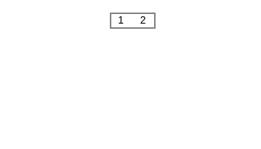
Insert > 2

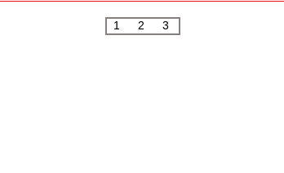
Insert > 3

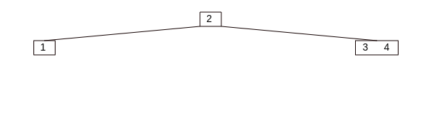
Insert > 4

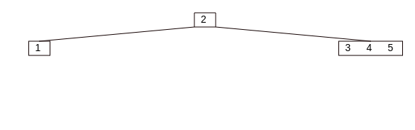
Insert > 5

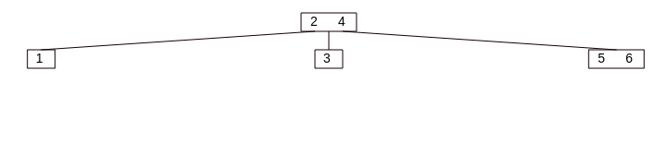
Insert > 6

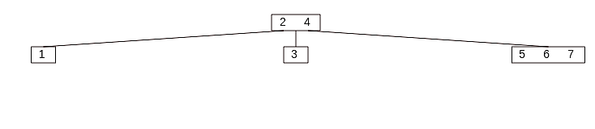
Insert > 7

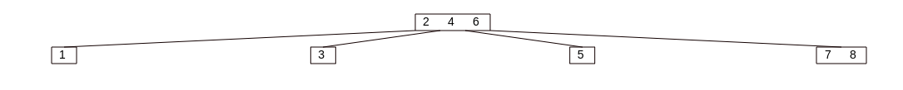
Insert > 8

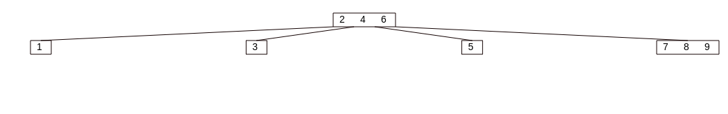
Insert > 9

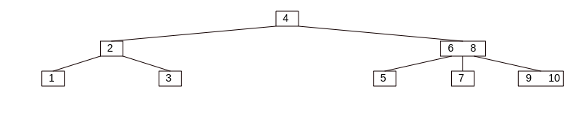
Insert > 10

Delete (Silme)

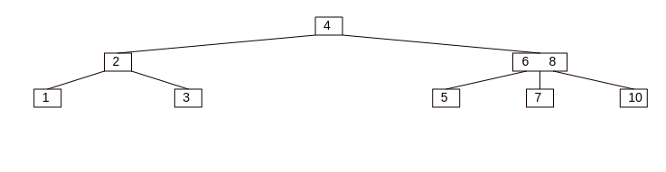
Delete > 9
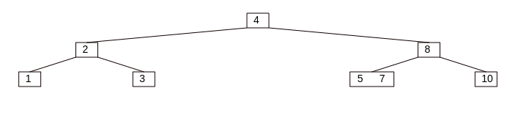
Delete > 6

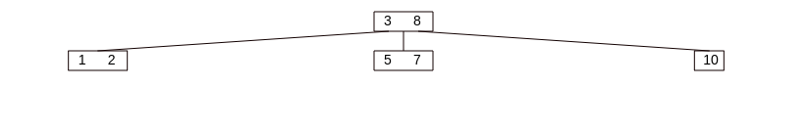
Delete > 4

